NAMA : Adi Saepul Anwar
NPM : 43A87006200129
MATKUL : JARKOM 2

Jawaban Soal UTS Praktek

No 2.

- Isi routing table Router 2

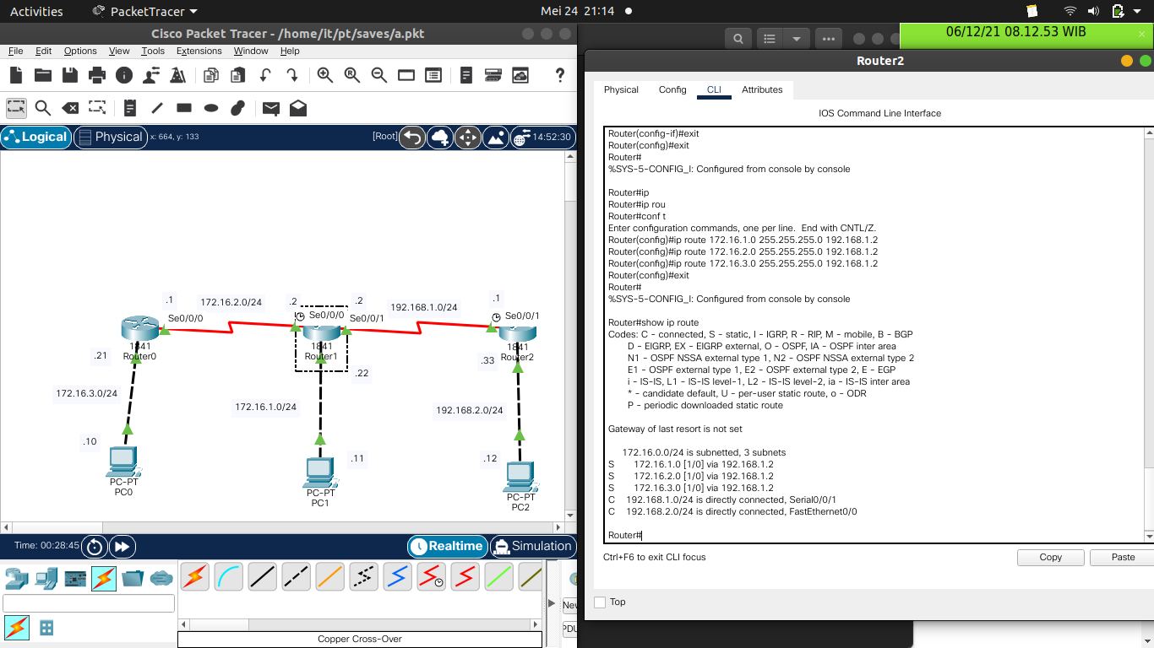

- Table routing Router 1

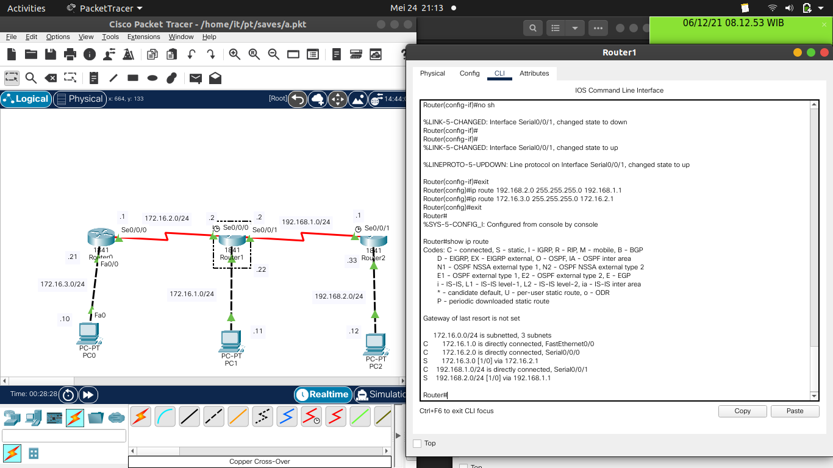

- Table routing Router 0

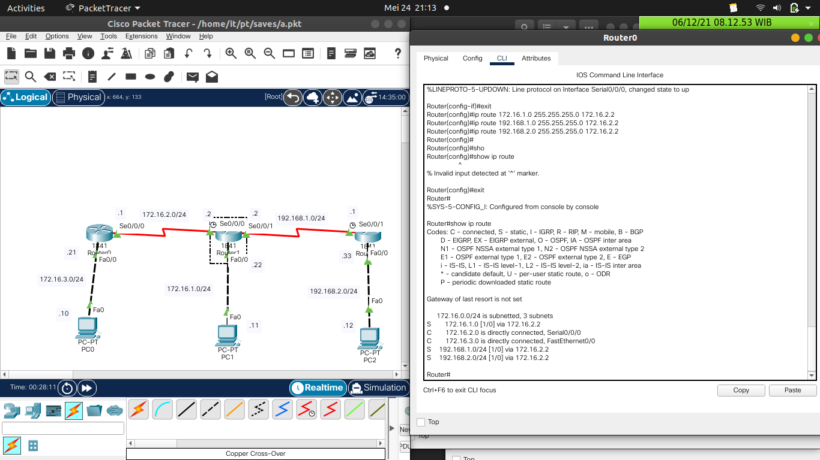

Soal B Praktek menyambungkan 2 PC

Topologi

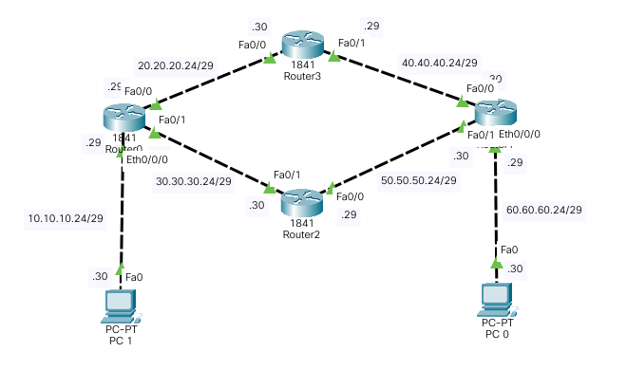

Ping Ke PC 0

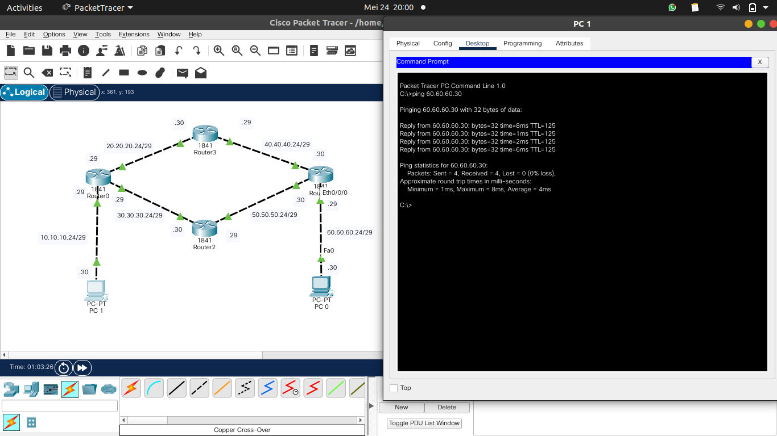

Ping Ke PC 1

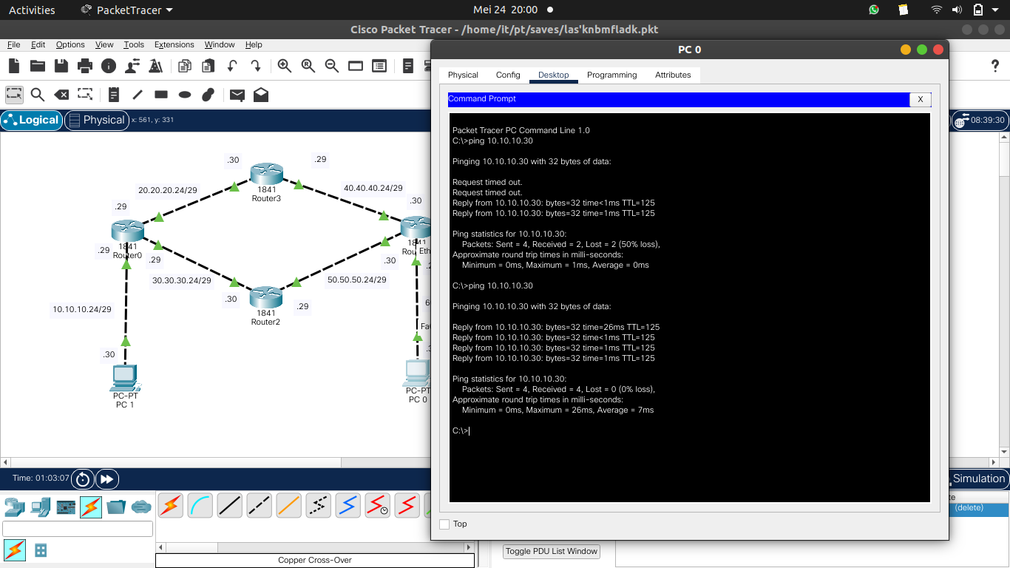

Router 0 | Router 1 | Router 2 | Router 3
10.0.0.0/29 is subnetted, 1 subnets  C 10.10.10.24 is directly connected, Ethernet0/0/0  20.0.0.0/29 is subnetted, 1 subnets  C 20.20.20.24 is directly connected, FastEthernet0/0  30.0.0.0/29 is subnetted, 1 subnets  C 30.30.30.24 is directly connected, FastEthernet0/1  40.0.0.0/29 is subnetted, 1 subnets  S 40.40.40.24 [1/0] via 20.20.20.30  50.0.0.0/29 is subnetted, 1 subnets  S 50.50.50.24 [1/0] via 30.30.30.30  60.0.0.0/29 is subnetted, 1 subnets  S 60.60.60.24 [1/0] via 20.20.20.30  [1/0] via 30.30.30.30 | 10.0.0.0/29 is subnetted, 1 subnets  S 10.10.10.24 [1/0] via 40.40.40.29  [1/0] via 50.50.50.29  20.0.0.0/29 is subnetted, 1 subnets  S 20.20.20.24 [1/0] via 40.40.40.29  30.0.0.0/29 is subnetted, 1 subnets  S 30.30.30.24 [1/0] via 50.50.50.29  40.0.0.0/29 is subnetted, 1 subnets  C 40.40.40.24 is directly connected, FastEthernet0/0  50.0.0.0/29 is subnetted, 1 subnets  C 50.50.50.24 is directly connected, FastEthernet0/1  60.0.0.0/29 is subnetted, 1 subnets  C 60.60.60.24 is directly connected, Ethernet0/0/0 | 10.0.0.0/29 is subnetted, 1 subnets  S 10.10.10.24 [1/0] via 30.30.30.29  20.0.0.0/29 is subnetted, 1 subnets  S 20.20.20.24 [1/0] via 30.30.30.29  30.0.0.0/29 is subnetted, 1 subnets  C 30.30.30.24 is directly connected, FastEthernet0/1  40.0.0.0/29 is subnetted, 1 subnets  S 40.40.40.24 [1/0] via 50.50.50.30  50.0.0.0/29 is subnetted, 1 subnets  C 50.50.50.24 is directly connected, FastEthernet0/0  60.0.0.0/29 is subnetted, 1 subnets  S 60.60.60.24 [1/0] via 50.50.50.30 | 10.0.0.0/29 is subnetted, 1 subnets  S 10.10.10.24 [1/0] via 20.20.20.29  20.0.0.0/29 is subnetted, 1 subnets  C 20.20.20.24 is directly connected, FastEthernet0/0  30.0.0.0/29 is subnetted, 1 subnets  S 30.30.30.24 [1/0] via 20.20.20.29  40.0.0.0/29 is subnetted, 1 subnets  C 40.40.40.24 is directly connected, FastEthernet0/1  50.0.0.0/29 is subnetted, 1 subnets  S 50.50.50.24 [1/0] via 40.40.40.30  60.0.0.0/29 is subnetted, 1 subnets  S 60.60.60.24 [1/0] via 40.40.40.30

Table Routing

Penghitungan Subnet

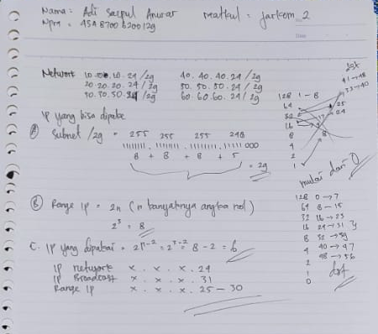

Konfigurasi

Router 0
Router#show running-config
Building configuration...

Current configuration : 877 bytes
!
version 12.4
no service timestamps log datetime msec
no service timestamps debug datetime msec
no service password-encryption
!
hostname Router
!
!
!
!
!
!
!
!
no ip cef
no ipv6 cef
!
!
!
!
!
!
!
!
!
!
!
!
spanning-tree mode pvst
!
!
!
!
!
!
interface FastEthernet0/0
ip address 20.20.20.29 255.255.255.248
duplex auto
speed auto
!
interface FastEthernet0/1
ip address 30.30.30.29 255.255.255.248
duplex auto
speed auto
!
interface Ethernet0/0/0
ip address 10.10.10.29 255.255.255.248
duplex auto
speed auto
!
interface Vlan1
no ip address
shutdown
!
ip classless
ip route 40.40.40.24 255.255.255.248 20.20.20.30
ip route 50.50.50.24 255.255.255.248 30.30.30.30
ip route 60.60.60.24 255.255.255.248 30.30.30.30
ip route 60.60.60.24 255.255.255.248 20.20.20.30
!
ip flow-export version 9
!
!
!
!
!
!
!
!
line con 0
!
line aux 0
!
line vty 0 4
login
!
!
!
end

Router 1

Router#show running-config
Building configuration...

Current configuration : 877 bytes
!
version 12.4
no service timestamps log datetime msec
no service timestamps debug datetime msec
no service password-encryption
!
hostname Router
!
!
!
!
!
!
!
!
no ip cef
no ipv6 cef
!
!
!
!
!
!
!
!
!
!
!
!
spanning-tree mode pvst
!
!
!
!
!
!
interface FastEthernet0/0
ip address 40.40.40.30 255.255.255.248
duplex auto
speed auto
!
interface FastEthernet0/1
ip address 50.50.50.30 255.255.255.248
duplex auto
speed auto
!
interface Ethernet0/0/0
ip address 60.60.60.29 255.255.255.248
duplex auto
speed auto
!
interface Vlan1
no ip address
shutdown
!
ip classless
ip route 10.10.10.24 255.255.255.248 50.50.50.29
ip route 10.10.10.24 255.255.255.248 40.40.40.29
ip route 20.20.20.24 255.255.255.248 40.40.40.29
ip route 30.30.30.24 255.255.255.248 50.50.50.29
!
ip flow-export version 9
!
!
!
!
!
!
!
!
line con 0
!
line aux 0
!
line vty 0 4
login
!
!
!
end

Router 2

Router#show running-config
Building configuration...

Current configuration : 1249 bytes
!
version 12.4
no service timestamps log datetime msec
no service timestamps debug datetime msec
no service password-encryption
!
hostname Router
!
!
!
!
!
!
!
!
no ip cef
no ipv6 cef
!
!
!
!
!
!
!
!
!
!
!
!
spanning-tree mode pvst
!
!
!
!
!
!
interface FastEthernet0/0
ip address 50.50.50.29 255.255.255.248
duplex auto
speed auto
!
interface FastEthernet0/1
ip address 30.30.30.30 255.255.255.248
duplex auto
speed auto
!
interface FastEthernet0/0/0
switchport mode access
switchport nonegotiate
!
interface FastEthernet0/0/1
switchport mode access
switchport nonegotiate
!
interface FastEthernet0/0/2
switchport mode access
switchport nonegotiate
!
interface FastEthernet0/0/3
switchport mode access
switchport nonegotiate
!
interface Serial0/1/0
no ip address
clock rate 2000000
shutdown
!
interface Serial0/1/1
no ip address
clock rate 2000000
shutdown
!
interface Vlan1
no ip address
shutdown
!
ip classless
ip route 40.40.40.24 255.255.255.248 50.50.50.30
ip route 60.60.60.24 255.255.255.248 50.50.50.30
ip route 20.20.20.24 255.255.255.248 30.30.30.29
ip route 10.10.10.24 255.255.255.248 30.30.30.29
!
ip flow-export version 9
!
!
!
no cdp run
!
!
!
!
!
!
line con 0
!
line aux 0
!
line vty 0 4
login
!
!
!
end

Router 3

Router#show running-config
Building configuration...

Current configuration : 1249 bytes
!
version 12.4
no service timestamps log datetime msec
no service timestamps debug datetime msec
no service password-encryption
!
hostname Router
!
!
!
!
!
!
!
!
no ip cef
no ipv6 cef
!
!
!
!
!
!
!
!
!
!
!
!
spanning-tree mode pvst
!
!
!
!
!
!
interface FastEthernet0/0
ip address 20.20.20.30 255.255.255.248
duplex auto
speed auto
!
interface FastEthernet0/1
ip address 40.40.40.29 255.255.255.248
duplex auto
speed auto
!
interface FastEthernet0/0/0
switchport mode access
switchport nonegotiate
!
interface FastEthernet0/0/1
switchport mode access
switchport nonegotiate
!
interface FastEthernet0/0/2
switchport mode access
switchport nonegotiate
!
interface FastEthernet0/0/3
switchport mode access
switchport nonegotiate
!
interface Serial0/1/0
no ip address
clock rate 2000000
shutdown
!
interface Serial0/1/1
no ip address
clock rate 2000000
shutdown
!
interface Vlan1
no ip address
shutdown
!
ip classless
ip route 10.10.10.24 255.255.255.248 20.20.20.29
ip route 30.30.30.24 255.255.255.248 20.20.20.29
ip route 50.50.50.24 255.255.255.248 40.40.40.30
ip route 60.60.60.24 255.255.255.248 40.40.40.30
!
ip flow-export version 9
!
!
!
no cdp run
!
!
!
!
!
!
line con 0
!
line aux 0
!
line vty 0 4
login
!
!
!
end

